PRESS RELEASE JDN123

NEW RADIO REMOTE CONTROLS FOR HOISTS AND CRANES

J D Neuhaus (JDN), the world leader in air hoists, cranes, trolleys and monorail hoists, has further enhanced their remote control capabilities. This innovation will bring exceptional ease-of-use and convenience to users across all industries. Three remote control models are now available, RC-X, RC-S and RC-SP, each comprising of a transmitter and receiver and all can either be integrated in existing JDN solutions or directly combined with a new JDN hoist.

One of the many advantages of the new JDN receiver is its rigid and extremely compact design. All components are housed in a space-saving, shock-resistant GRP (glass-reinforced plastic) casing featuring protection class IP65 (dust and water protected). A breathable membrane guides any condensation away from the interior to the exterior. The design also offers seawater-resistance for offshore applications. The radio remote control model RC-X is even suitable for the use in potentially explosive environments rated up to ATEX zone 2/22.

Consideration has also been given to ease-of-installation. Even existing JDN hoists and cranes can be retrofitted thanks to the standardized interface of the JDN RC. The receiver can be mounted directly on the hoist or the trolley, or individually at site. The compact design of the receiver makes it even suitable for hoists with low carrying capacity.

Individual solutions according to specific customer needs are available. Up to 20 hours of use is possible before recharging of the portable transmitter is required.
Continued ……
Perfect for covering long distances between hoist and operator, the JDN RC represents a sensitive alternative to applications with long control hoses. In addition, it can be used in hard-to-reach places and for simultaneous control of multiple hoists.

JDN’s decision to develop electronic-based radio remote controls as a renowned designer and manufacturer of exclusively pneumatic and hydraulic hoists and cranes may be surprising. Certainly, continuous innovation has been a long-lasting ethos at JDN. Thanks to a series of industrial firsts the company enjoys an ever increasing market share in the field of lifting technology.

Company information
JDN located in Witten, Germany, has over 200 employees worldwide and is a manufacturer for pneumatic and hydraulic hoisting devices and crane systems. Its internationally unique specialization sets the benchmark for quality in their field. With customers in over 90 countries J D Neuhaus is furthermore also the world market leader. The products are characterized by their ability to steadily and reliably move loads of up to 115 tons even under the most extreme conditions. This also includes the protection against explosion. JDN products are e.g. used in the field of gas and oil movement, under arctic temperatures down to -45°C, under water for ship repairs, for mining applications, in the chemicals industry, for heavy machinery construction and in various areas of logistics. J D Neuhaus supplies a total of around 70 industries.

Production exclusively takes place at the JDN headquarter in Witten, Germany. The wide range of products is complemented by services such as installation, inspection, maintenance, general overhaul of the systems and individual trainings for customers.

In collaboration with international partners and JDN subsidiaries in France, Great Britain, Singapore, and the United States, the company has developed a close-knit distribution network that spans the globe. J D Neuhaus has an export rate of over 80%.

Continued ……
Founded in 1745 the company is now family-owned in the seventh generation. The hoisting device museum worth visiting at the JDN headquarter in Witten, Germany, showcases the company’s history as a lively part of corporate culture.

Further information is available on request to:
J D Neuhaus L.P., 9 Loveton Circle, MD 21152 Sparks, USA
Contact: Peggy Weber e-mail: p.weber@jdneuhaus.com
Office Phone: 1-888- NEUHAUS www.jdngroup.com

Worldwide contact details for J D Neuhaus can be seen at the end of this press release.

facebook.com/jdneuhaus twitter.com/JD_Neuhaus

(approximately 650 words
including photographic annotations)

General Information

Supplier: J D Neuhaus L.P.

Press Release No: JDN123

Press or publishing inquiries to: Steve Lloyd
Enterprise Marketing Services Ltd
The Coach House, 1 Dunstall Road, Barton under Needwood,
Burton on Trent, Staffordshire, DE13 8AX, UK
Tel: +44 (0) 1283 713185
Fax: +44 (0) 1283 716172
e-mail: info@enterprise-marketing.co.uk

Reader response inquiries to: Ms Peggy Weber of J D Neuhaus L.P.

Downloads: The press release text (MS Word and PDF format) and images are
available for download at:

www.enterprise-marketing.co.uk/jdn/jdn123.html

Our Reference: JDN123/18/06/V3

Continued ……
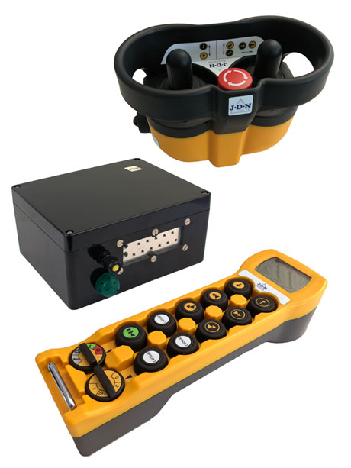
The RC-S and RC-SP radio control remote control transmitters and receiver from J D Neuhaus, for the safe and convenient control of hoists and cranes.
Download high resolution 300dpi image (1800 x 2400 px)
Download low resolution 72dpi image (800 x 600 px)

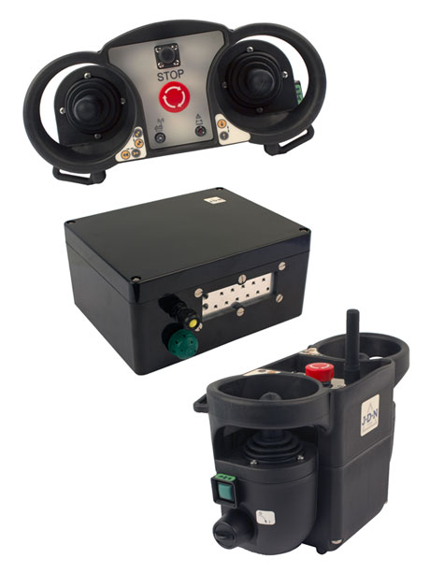
The J D Neuhaus receiver and RC-X radio control remote control transmitters and receiver, for safe hoist and crane control.
Download high resolution 300dpi image (1800 x 2400 px)
Download low resolution 72dpi image (800 x 600 px)
Continued ……
Company information

J D Neuhaus are a privately-owned company, founded in 1745, and for over 270 years they have been using their expertise and experience to manufacture the highest quality hoists and cranes.

Their products offer solutions to almost every material handling problem irrespective of the driving medium: from air and hydraulic hoists up to complete crane installations with explosion proofness.

JDN products are used in a wide variety of industries including:
Airplane Yards; Atomic/Coal Power Stations; Big Bag Handling; Cement Industry; Chemical Industry;
Crane Manufacturers; Dairies; Food Industry; Foundries; Galvanization; Glass/Ceramics; Large Kitchens;
Leather Plants; Locks; Machine and Plant Construction; Mining; Motor Car Industry; Offshore/Onshore;
Oil Storage; Over/Underground Construction; Paints and Varnish; Painting and Coating Installations;
Paper Industry; Pharmaceutical Industry; Printing Industry; Pyrotechnics Industries; Refineries; Sawmills; Shipbuilding and Shiprepair Yards; Ships; Space Technique; Spray Booths; Steel Works; Surface Technique;
Tank Cleaning Devices; Textile Industry; Tunnel; Tire Manufacturers; Vacuum Technique

Contact J D Neuhaus

J D Neuhaus are represented in more than 90 countries and over 70 branches Worldwide.

Germany
J D Neuhaus GmbH & Co. KG, 58449, Witten-Heven, Germany
Tel: +49 2302 208-219 Fax: +49 2302 208-286
e-mail: info@jdngroup.com www.jdngroup.com

France
J D Neuhaus S.A.R.L., 24, rue du Président Krüger, 69008, Lyon, France
Tel: +33 4 3790-1745 Fax: +33 4 3790-1746
e-mail: info@jdneuhaus.fr www.jdngroup.com

Great Britain
J D Neuhaus Ltd, Unit 6 Kirkton Avenue, Pitmedden Road Industrial Estate, Dyce, Aberdeen, AB21 0BF, UK
Tel: +44 1224 722751 Fax: +44 1224 729895
e-mail: info@jdneuhaus.co.uk www.jdngroup.com

Singapore
J.D. Neuhaus Pte. Ltd, 21 Toh Guan Road East, #09-02 Toh Guan Centre, 608609, Singapore
Tel: +65 62758911 Fax: +65 62758922
e-mail: info@jdn.com.sg www.jdngroup.com

USA
J.D. Neuhaus L.P., 9 Loveton Circle, MD 21152 Sparks, USA
Tel: +1-410 472-0500 Fax: +1-410 472-2202
e-mail: info@jdneuhaus.com www.jdngroup.com

